Student ID: **301015001**

Student: **Nedim Ćato**

Project Proposal

**WBC (World Bank of Cato)**

1. **Introduction**

A WBC online banking system is a management information system for online transactions such as sending and receiving money or selling and buying things that you find on internet. We in WBC will propose the development of easier managing of your money which will provide capabilities for you to easily buy/sell items,goods etc. and being able to review your bank account at any time of the day and besides that you can send or receive money online.

WBC is the safer, easier way to pay and get paid online. The service allows anyone to pay in any way they prefer, including through credit cards, bank accounts or account balances, without sharing financial information.

1. **Objectives**

**...**

1. **Application Features and Description**

**WBC** will provide functionalities for:

* Enabling online application
* Enrolling new clients and handling the registration process
* Maintenance and reporting of client's account (transactions,balance,deposit,withdraw of money..)
* Checking account details such as balance,credit number,contacts ets.
* Transactions (receiving and sending money)
* Personal Information (Email adresses,phone number,adresses)
* Login and Security (See your photo, payment preferences and more before you log in.)
* Being able to see your overall activity (payments received,payments sent)

**Enabling online application**

At the first time of applying to our bank application you need to fill online application form which represent electronic application for the buying/selling, online transaction of money and review of your bank account at any time of the day. Online application requires basic personal data from which some of them are marked as required.

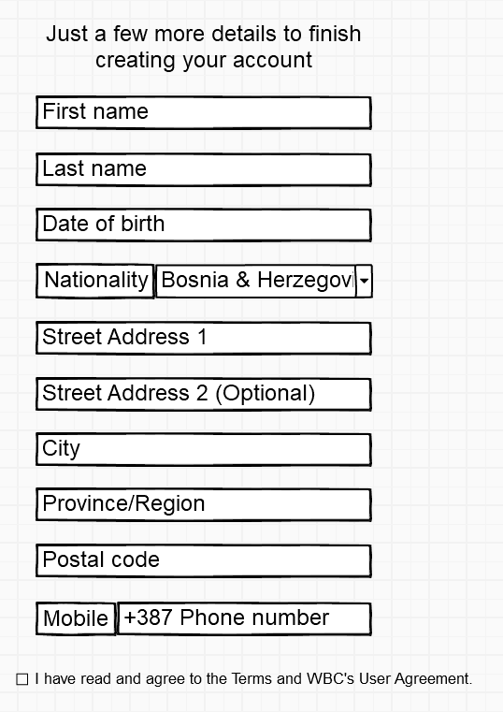 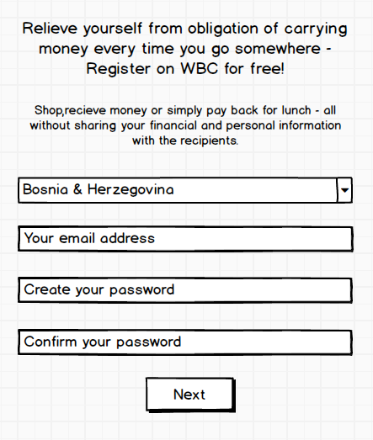On registration form you enter your basic information about yourself.

Next step brings you here where you enter all your personal information with our application.

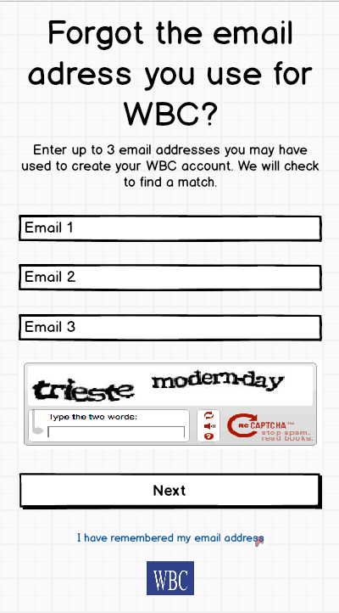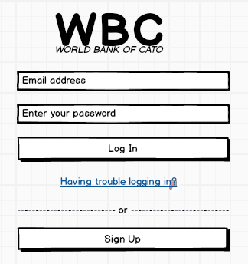For those that are already registered they can press on log in and enter into their account very easily by entering email and password.

For those that forgot their email we ensure you to gain your access easily.